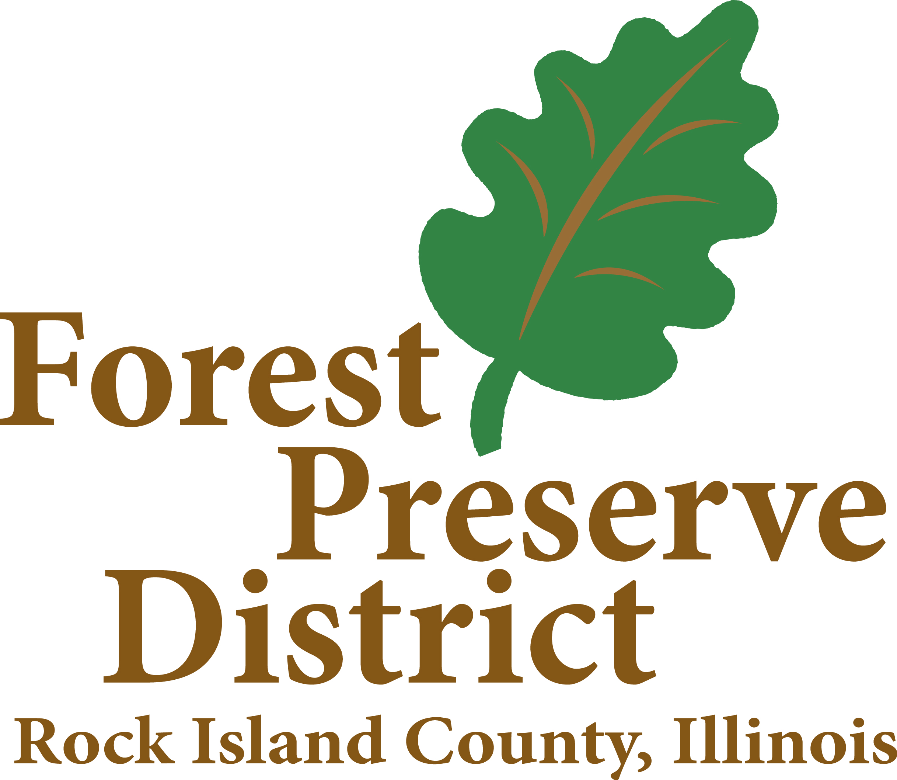
Rock Island County Forest Preserve District
PURPOSE:
The Forest Preserve District of Rock Island County is a body corporate and politic of the State of Illinois. The Rock Island County Forest Preserve was organized under the Downstate Forest Preserve Act which gives the District the power to create forest preserves, and for that purpose shall have the power to acquire and hold lands containing one or more natural forests or parts thereof or land or lands connecting such forests or parts thereof, or lands capable of being forested, or capable of being restored to a natural condition, for the purpose of protecting and preserving the flora, fauna, and scenic beauties within such district, and to restore, restock, protect and preserve the natural forests and such lands together with their flora and fauna, as nearly as may be, in their natural state and condition, for the purpose of the education, pleasure, and recreation of the public.

GOVERNING BODY:
The Rock Island County Forest Preserve Commission is the governing body of the District. The 19 County Board members are ex-officious and serve as the Rock Island County Forest Preserve Commission. The Commission conducts its business typically on the 3rd Tuesday of the month after the 5:30 PM meeting of the Rock Island County Board, 1504 3rd Ave, Rock Island, IL 61201. The Commission elects a president during even numbered years on the first Monday of December. The president elect nominates a secretary, treasurer and auditor for the Commission who serve as simultaneous term as the president.

OFFICE LOCATIONS:
Loud Thunder Park & District Offices, 19406 Loud Thunder Road, Illinois City, IL 61259. (309)795-1040
Niabi Zoo Administrative Offices, 13010 Niabi Zoo Road, Coal Valley, IL 61240 (309)799-3482
Indian Bluff Golf Course Offices, 6200 78th Ave, Milan, IL 61265 (309)-799-3868
Illiniwek Park Office, 836 State Ave, Hampton, IL 61256 (309)496-2620

TOTAL OPERATING BUDGET: Total $8,626,990 (FY 26)
Administration $1,414,929
Illiniwek $585,252
Loud Thunder $619,981
Indian Bluff Golf Course $972,152
Dorrance $12,088
Bike Path $5,000
Niabi Zoo $4,169,884
FICA & IMRF $419,666
Liability $383,038
Audit $45,000

EMPLOYEES:
The District employs 37 full-time employees and 108 temporary/seasonal employees
Jeffrey Craver – District Director;
Cassie Sullivan - Administrative Assistant;
Mike Petersen - Illiniwek Site Superintendent;
Jay Verstraete - Indian Bluff Golf Superintendent;
Todd Collins – Clubhouse Manager;
Lee Jackson - Niabi Zoo Director;
Ben Mills - Ranger Loud Thunder Site Superintendent;

DESIGNATED PERSON TO RECEIVE REQUESTS & FOIA OFFICER:
Jeffrey Craver, District Director

HOURS TO INSPECT/REVIEW REQUESTS: 8 AM to 4:00 PM Mon thru Fri
OFFICE HOURS: 8 AM to 4:00 PM Mon thru Fri

RECORDS ON FILE: Executive Committee and Commission meeting minutes, Monthly attendance & fee reports for Golf, Zoo, and Camping, Resolutions & Transfers, Contracts and Agreements, Budget Appropriations, Levy Ordinances, Expense & Revenue Reports, Annual Financial Report, Procedure & Employment Manual, Inventory Records, Federal State and County Liquor License Information, Vehicle title and license records.

FUNCTIONAL DIVISIONS:

